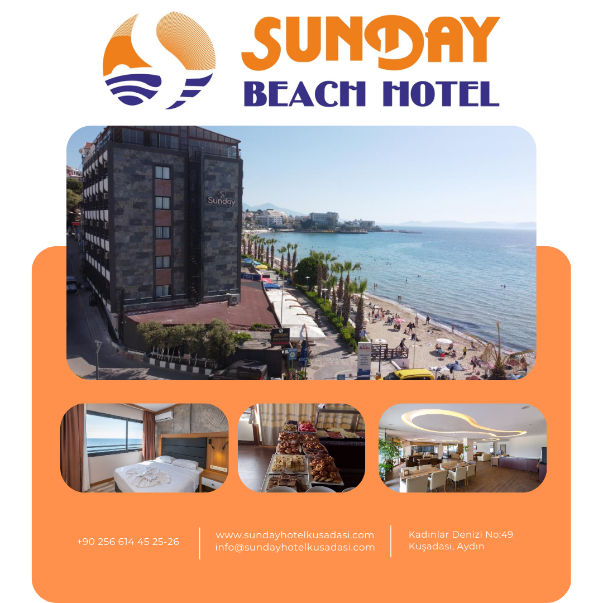

Ministry of Culture and Tourism-Accommodation Certificate:2022-9-0416

Our Website:www.sundayhotelkusadasi.com
Our Mail adress:info@sundayhotelkusadasi.com


Rooms:
Hotel Sunday Beach is a stylish seafront hotel located at Ladies Beach, Kuşadası, offering rooms with balconies that provide stunning sea and land views.
Our rooms are equipped with 32-inch LCD TVs, air conditioning, a hairdryer, minibar, safe, and free Wi-Fi. The rooms range from 17 to 20 m² in size and can accommodate up to 3 guests.

Location:
City Center: 3 km
Dilek Peninsula National Park: 20 km
Didim: 70 km
Izmir Adnan Menderes Airport: 70 km
Ephesus Ancient City: 21 km
Distance to the sea: 0 m (Ladies Beach)

Dining and Drinks:
Hotel Sunday Beach offers a rich menu featuring both local and international flavors. Guests can enjoy breakfast and dinner prepared with fresh seasonal ingredients in the restaurant. Additionally, there is a bar that serves a variety of cocktails throughout the day. Our à la carte restaurant offers a refined menu with exquisite flavors.

Beach:
The famous Ladies Beach, located just a few steps from the hotel, is available for free use.

Services and Amenities:
Hotel Sunday Beach provides 24-hour reception service and high-speed internet access for all guests. Additionally, the hotel offers a free private parking lot for guest use. For groups of more than 20 people, an open buffet service is available.

Summary:
• Seafront location
• Modern and comfortable rooms
• Free Wi-Fi and parking
• Local and international cuisine options
• À la carte restaurant and bar
• 24-hour reception service
• Close proximity to Ladies Beach
• Public beach with free umbrellas and sunbeds
Hotel Sunday Beach is waiting to offer you a delightful vacation experience in Kuşadası!

