**2023 HOTEL FACT SHEET**

**LOCATION**

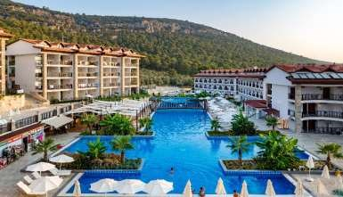

Ramada Resort Akbük was opened in Didim Akbük Bay in 17 May 2014.

The facility established on 22.000 m² area is providing a wonderful visual feast to its guests where green and blue embrace each other thanks to its location overlooking to entire view of Akbük Bay.

Ramada Resort Akbük provides you the holiday of your dreams by combining quality, comfort and entertainment with a clean and calm nature.

|  |  |
| --- | --- |
| **Name of the hotel** | **RAMADA RESORT AKBÜK** |
| **Brand** | **WYNDHAM RAMADA®** |
| **Hotel Concept** | **All Inclusive during 24 hours** |
| **Hotel Area** | **22.000 m²** |
| **Number of Rooms** | **369** |
| **Number of Buildings** | **8 Blocks** |
| **Number of Floors** | **4** |
| **Number of Lifts** | **8** |
| **Address** | **Akbük Mah. 3044 Sokak No:46** |
| **Telephone** | **0256 856 52 52 (pbx)** |
| **Fax** | **0256 856 52 50** |
| **Web Site** | [www.ramadaresortakbuk.com](http://www.ramadaresortakbuk.com/) |
| **Social Media Links** | facebook.com/ ramadaresortakbuk, twitter.com/ ramadaakbuk instagram.com/ ramadaresortakbuk |
| **E-mail** | sales@ramadaresortakbuk.com |
| **Opening Year** | **2014** |
| **Last Renovation** | **2019** |
| **Seasonal Opening Date** | **30.04.2023** |
| **Seasonal Closing Date** | **15.10.2023** |

# DIRECTIONS

|  |  |  |  |  |  |  |  |  |  |  |  |  |  |  |  |  |  |  |  |  |  |  |  |
| --- | --- | --- | --- | --- | --- | --- | --- | --- | --- | --- | --- | --- | --- | --- | --- | --- | --- | --- | --- | --- | --- | --- | --- |
| |  |  | | --- | --- | | **Didim City Center** | 20 km | | **Bus Station** | Hotel Entrance | | **Akbük City Center** | 1500 m | | **Beach** | 1200 m | | **Bodrum Airport** | 60 km | | **İzmir Airport** | 142 km | | **Bodrum City Center** | 100 km | | **Kuşadası** | 75 km | | **Apollon Temple** | 20 km | | **Priene Ancient City** | 47 km | | **Heraklia** | 44 km | |  |

|  |  |  |
| --- | --- | --- |
| **ACCOMODATION** |  |  |
|  |  |  |
| **ROOM TYPES** | **Number** | **Bed Types** |
| **Standard Double Room** | 165 | 1 double bed or 2 twin beds / 1 Sofa Bed |
| **Standard Large Room** | 104 | 1 double bed + 1 twin bed or 3 twin beds / 1 Sofa Bed |
| **Superior Bunk Bed Room** | 100 | 1 double bed + 1 Bunk Bed + 1 twin bed / 1 Sofa Bed |
| **Family Room** | 4 | 1 double bed + 1 twin bed / 1 Sofa Bed |
| **Duplex Family Room** | 7 | 1 double bed + 1 twin bed / 1 Sofa Bed |
| **Family Eko Room** | 10 | 1 double bed + 2 twin beds / 1 Sofa Bed |
| **Handicap Room** | 2 | Combinable 2 twin beds |
| **Sea/Side Sea View Rooms** | 138 | -- |
| **Land/Garden View Rooms** | 231 | -- |
| **Total Rooms** | 369 | -- |

|  |
| --- |
| **ROOM FEATURES** |
| 32 Inc LCD TV, national and international satellite |
| Free WiFi |
| Kettle + Tea & Coffee Setup |
| Daily Fresh Water |
| Minibar |
| Safety Box |
| Individual Air Conditioner |
| Telephone |
| Wake-Up Service |
| 220 Volt Electrical Socket |
| Laminated flooring |
| Desk |
| Full-length mirror |
| All rooms have a wide balcony or terrace |
| In bathrooms; shower, WC, hair dryer, towel, bathroom amenities (shampoo, conditioner, shower gel and soap) |

* 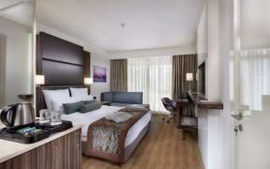In all rooms towels are changed on daily basis and bed linens are changed every three days.
* All rooms are non-smoking rooms. Smoking is allowed in balcony or terrace.

# GENERAL FEATURES

|  |  |  |  |
| --- | --- | --- | --- |
|  | **FREE SERVICES** | |  |
| **Parking Lot** | **Turkish Bath** | **24 Hour Reception Service** | **Sun Terrace** |
| **Business Center** | **Sauna** | **24 Hour Security Service** | **Lift** |
| **Wireless Internet Access** | **Steam Bath** | **Bellboy Service** | **Safety Box** |
| **Shuttle Service to Beach** | **Fitness** | **Daily Newspaper at Lobby** | **Baby Cot** (0 - 3 Years) |

|  |  |  |
| --- | --- | --- |
|  | **PAID SERVICES** |  |
| **24 Hour Room Service** | **Medical Services** | **Market** |
| **Laundry Service** | **Gift Shop** | **Telephone Calls** |
| **Minibar Service** | **Photographer** | **Fax - Photocopy** |
| **Massages and Beauty Care** | **Hair Dresser** |  |

* Check-in is at 15:00 o’clock. ➢ Check-out is at 12:00 o’clock.
* Please keep your valuables in the safety boxes available in all rooms as well as in the reception.
* It is forbidden to smoke in all indoor areas according to the Law No. 4207.
* Pets are not allowed at our hotel.
* Please contact Guest Relations for your all questions and concerns.
* Please keep your wrist band which is given during check-in in order to benefit from all-inclusive service.

# HOTEL FACILITIES

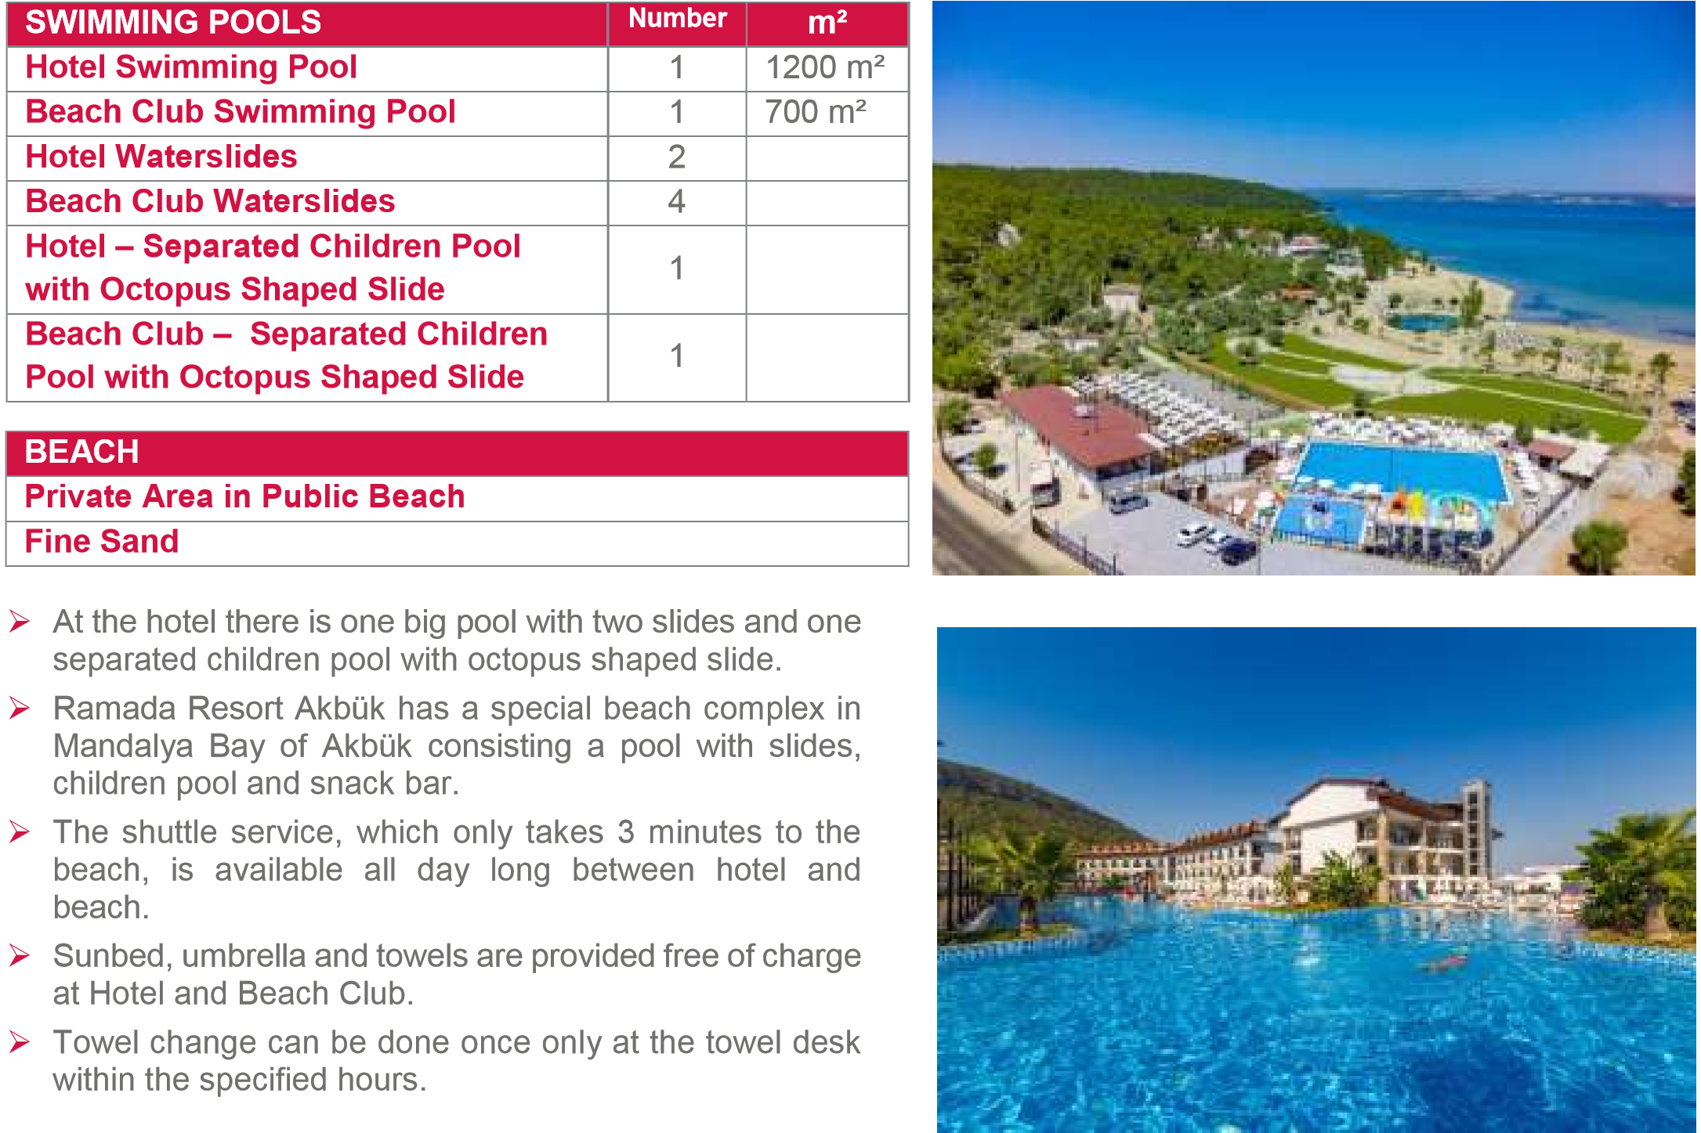

**ENTERTAINMENT**

* You will have as much fun as you want thanks to day long sports and animation activities in Ramada Resort Akbük Beach volley, table tennis, dart and similar activities are available during daytime activities.
* In the evenings, you will have fun with music, dance shows and mini disco for children.

|  |  |  |
| --- | --- | --- |
| **FOR CHILDREN** | **Hours** | **Age** |
| **Mini Club and Game Garden** | 10:00 – 17:00 | 4 - 12 |
| **Mini Disco** | 20:30 – 21:00 | -- |
| **Children Pool with Octopus Shaped Slide at the Hotel and the Beach** | -- | -- |
| **Baby Cot** | -- | 0 - 3 |
| **Special baby care units are available in the hotel.** | |  |
| **Baby feeding chair is available in the main restaurant and snack restaurants.** | |  |
|  | |  |
| **SPA & WELLNESS** | |  |

* 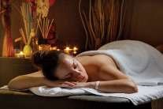At our SPA center, you will have a peaceful atmosphere where you can rest your body and mind at the same time.

* There are Turkish bath, tepidness area, sauna, massage rooms, steam house, tepidarium, hot stone beds, adventure shower, resting room, showers and fitness center in our SPA Center.

* All services other than massage types and beauty cares are free of charge in our SPA Center.

# FOOD & BEVERAGE CONCEPT

➢ All kind of soft drinks and local drinks are provided within the all-inclusive concept. The provided local drinks within the All-inclusive concept are gin, vodka, raki, beer and wine (red, white and rosé). **Brands are determined by the hotel management.**

|  |  |
| --- | --- |
| **MANDALYA RESTAURANT** | **Hours** |
| **Breakfast** (Open Buffet) | 07:00 – 10:00 |
| **Late Breakfast** (Mini Buffet) | 10:00 – 11:00 |
| **Lunch** (Open Buffet) | 12:30 – 14:30 |
| **Dinner** (Open Buffet) | 19:00 – 21:30 |
| **Midnight Soup** (Open Buffet) | 24:00 – 01:00 |
| ➢ Fresh orange juice is extra charged. |  |

|  |  |  |  |  |  |  |  |  |  |  |
| --- | --- | --- | --- | --- | --- | --- | --- | --- | --- | --- |
| |  |  |  | | --- | --- | --- | | **RESTAURANT CAPACITY** | | | | **Total Capacity** | **Indoor** | **Outdoor** | | 1050 pax | 350 pax | 700 pax | |  |
| |  |  | | --- | --- | | **POOL SNACK RESTAURANT & POOL BAR** | **Hours** | | **Pool Snack Buffet** | 12:00 – 17:00 | | **Dessert / Fruit Service** | 12:00 – 17:00 | | **Pool Bar Service** | 10:00 – 18:00/ 19:00 – 24:00 | | ➢ Import drinks and cocktails are extra charged. |  | |
| |  |  | | --- | --- | | **BEACH SNACK RESTAURANT & BEACH BAR** | **Hours** | | **Beach Snack Buffet** | 11:00 – 17:00 | | **Turkish Pancake Service** | 12:00 – 17:00 | | **Beach Bar Service** | 10:00 – 18:00 | | ➢ Import drinks and cocktails are extra charged. |  | |

|  |  |
| --- | --- |
| **CAFE CARAMEL** | **Hours** |
| **Cookies** | 11:00 – 18:00 |
| **Ice-cream** | 15:00 – 17:00 |
| **Drinks** (Tea and Coffee Types) | 10:00 – 24:00 |
| ➢ Turkish coffee, water pipe and birthdays cakes are extra charged. | |

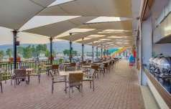

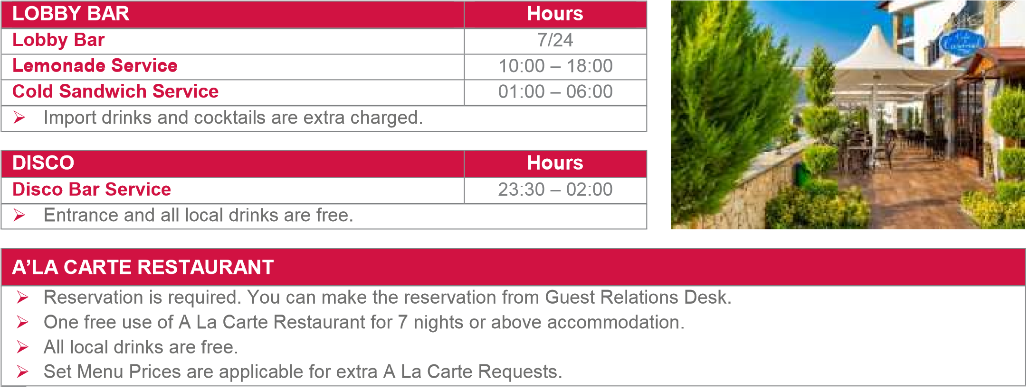

* The Hotel Management reserves its right to change any of the service hours depending on the weather conditions without prior notice.

|  |  |  |  |  |  |  |
| --- | --- | --- | --- | --- | --- | --- |
| **ALL INCLUSIVE CONCEPT PAYABLE SERVICES** | | | | | | |
| *Import Alcoholic Drinks & Soft Beverages | | |  | *Import & Local Bottle of Wines | | |
| *All kinds of bottled drinks |  | *Doctor (All medical assistance) | | |  | *Massage & All Treatments |
| *Room Service |  | *Minibar | | |  | *Specialty Coffiees |
| *Turkish Coffee |  | *Laundry & Ironing & Dry Cleaning | | |  | *Fresh Fruit Juices |
| **ALL INCLUSIVE CONCEPT FREE OF CHARGE SERVICES** | | | | | | |
| *Minibar (Bottle of Water) |  | *Turkish Bath & Sauna | | |  | *Fitness Center |
| *Safety Box |  | *A La Carte Restaurant (7 days +) | | | *Kids Club (Between 04-12 ages) | |
| *We changes your towels in the room every day , sheets every three days | | | | | | |
| **SHUTTLE SERVICE BETWEEN HOTEL & THE BEACH** | | | | | | |
| We have a free shuttle service between the hotel and the Beach Club all day For service hours, you can contact with guest relations, reception desk or security | | | | | | |
| From Hotel to Beach : 08:30 - 21:10 From Beach to Hotel : 08:40 - 21:30 | | | | | | |
| **IT IS PROHIBITED TO USE TOBACCO PRODUCTS CLOSED AREAS ACCORDING TO LAW NUMBER 4207 ( All rooms are non-smoking. Smoking is allowed in balcony or terrace)** | | | | | | |

|  |  |  |  |  |
| --- | --- | --- | --- | --- |
| **POOLS & RULES OF POOL** | | | | |
| Hotel Swimming Poll | : | 08:00 – 19:00 |  | * Children under the age of twelve,should be watched by their families * It is forbidden to dive and jump into the pool  * Don't let your children go into the pool without their diapers and swimsuit for the hygieneof the pool  * It is suggested that, Whose / Who have hypertension, heart condition and baby (pregnont), shouldn't go into the pool.  * Changing towel of beach should be done once a day.  * Adult pool depth 140 cm . * Kids part depth 40 cm. |
| Beach Swimming Pool | : | 08:00 – 18:00 |  |
| Waterslide Working Hours | : | 10:00 – 12:30 |  |
|  | : | 13:30 – 17:30 |  |
| Lifeguard Working Hours | : | 09:00 – 12:30 |  |
|  | : | 13:30 – 17:30 |  |
| Working Hours of towel room | : | 09:00 – 17:30 |  |
|  |  |  |  |